You Are My Sunshine 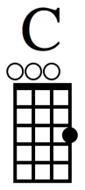 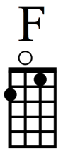

Intro: C

C C
Chorus: You are my sunshine my only sunshine
F C
You make me happy when skies are grey
F C
You’ll never know dear how much I love you
C G C
Please don’t take my sunshine away

C C
Verse 1: The other night dear as I lay sleeping
F C
I dreamed I held you in my arms
F C
When I awoke dear I was mistaken
C G C
Please don’t take my sunshine away

C C
Chorus: You are my sunshine my only sunshine
F C
You make me happy when skies are grey
F C
You’ll never know dear how much I love you
C G C
Please don’t take my sunshine away
C G C
Please don’t take my sunshine away

